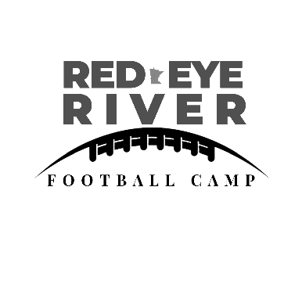

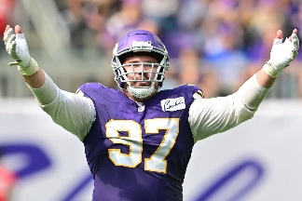

Guest coach Vikings player Harrison Phillips!
Register for our 4th annual Red Eye River Football Camp!
July 16th 2-4pm @ Menahga Highschool Football Field
July 17th 2-4pm @ Sebeka Highschool Football Field
July 18th 3-6pm @ Sebeka Highschool Football Field
Limited Spots! Free! K-6th Grade!
Questions contact Kim Rife 740-304-2996
___________________________________________________________
Name_______________________________________Grade______
Phone #___________________
School attends__________________________
Days you will attend: 1___, 2___,3___
Shirt Size YS___,YM___,YL___,YXL___,AS___,AM___,AL___,AXL___,AXXL___
Please mail registration form and waiver to:
Red Eye River Football PO Box 111,Park Rapids, MN 56470

